
the Engineering of Instagram



October 20, 2025
Mohammad atat Mohammad kashmar
ID:1123266 1123237


1.Introduction
1.1. Product Scope:
Instagram is a social networking application that allows users to share photos, videos, stories, and messages.
. It enables communication, expression, and discovery through visual content.
. The system includes:
- User registration and authentication
- Photo and video sharing
- Feed generation and recommendation
- Direct messaging and notifications
- Reels, Stories, and Live streaming features
- Interaction tools (likes, comments, shares, saves)
. The scope also covers backend systems for data storage, content delivery, and machine learning–based personalization.

1.2. Product Value:
Connectivity: Helps people connect, share experiences, and communicate visually.
• User Engagement: Provides an easy and attractive interface for continuous interaction.
• Business Growth: Supports marketing and advertising for brands and influencers.
• Global Reach: Scalable infrastructure allows billions of users to interact instantly.
• Data Insights: Uses AI and analytics to improve user experience and engagement.
• Entertainment and Discovery: Personalized recommendations for posts, reels, and stories keep users engaged.

1.3. Intended Audience:
- General Users: Individuals who want to share photos, videos, and connect with others.
- Content Creators/Influencers: Users who create content for entertainment or branding.
- Businesses and Advertisers: Companies that promote products or services.
- Developers and Engineers: Team members maintaining or improving the application.
- Researchers and Analysts: People studying social media trends and user behavior.

1.4. Intended Use:
- To share visual content such as images, videos, and reels.
- To interact socially through likes, comments, and direct messages.
- To follow and discover other users, trends, or topics.
- To advertise products and services through sponsored posts.
- To analyze engagement data for content improvement or marketing strategies.
- To build communities and foster communication around shared interests

1.5. General Description
Instagram is a mobile and web-based social media platform designed to provide a simple, engaging, and secure experience for sharing photos and videos.
It offers:
- A user-friendly interface for content creation and sharing.
- A personalized feed powered by machine learning algorithms.
- Real-time communication through direct messages and stories.
- Integration with Facebook’s ecosystem for authentication and ad services.
- Robust backend infrastructure ensuring performance, scalability, and security.
- Cross-platform availability (iOS, Android, and web browsers).

2.Functional Requirements:
. User Management
. Content Management
. Feed and Recommendation System
. User Interaction
. Search and Discovery
. Notifications
. Advertising and Business Features
. Security and Privacy
. Administration
. System Performance

3. External Interface Requirements

3.1 User Interface Requirements
The user interface (UI) of Instagram must be intuitive, responsive, and visually appealing across all platforms (mobile and web).

3.1.1 General Interface
- The UI shall provide a consistent layout on all supported devices (Android, iOS, and web browsers).
- The system shall display a navigation bar with key features:
  - Home (feed)
  - Search (explore)
  - Upload/Post
  - Reels
  - Profile
- The UI shall provide a top bar showing logo, messages, and notification icons.
- The interface shall adapt automatically to different screen sizes and orientations.

3.1.2 Feed Page
- Shall display posts from followed users and suggested content.
- Shall show interactive buttons for like ❤️, comment 💬, share ↗️, and save 📎.
- Shall update automatically when new content is posted.

3.1.3 Profile Page
- Shall display the user’s profile picture, bio, follower count, and posts.
- Shall include Edit Profile and Settings buttons.

3.1.4 Direct Messaging
- Shall display a chat list and individual chat windows.
- Shall support sending text, emojis, images, videos, and voice messages.

3.1.5 Accessibility
- Shall support dark and light modes.
- Shall support screen readers and text alternatives for images.
- Shall use clear icons and readable fonts for usability.

3.2 Hardware Interface Requirements
The Instagram application interacts with multiple hardware components depending on the user device.

3.2.1 Mobile Devices (Android/iOS)
- The system shall use the device camera for photo and video capture.
- The system shall access the microphone for video sound and voice messages.
- The system shall use the touchscreen for navigation and interaction.
- The system shall use storage memory to temporarily cache media files.
- The system shall support biometric sensors (fingerprint, face recognition) for login security (if enabled).

3.2.2 Server Hardware
- The backend servers shall include high-performance CPUs and GPUs for data processing and AI tasks.
- Servers shall use redundant storage systems for reliability and data recovery.
- Hardware load balancers shall be used to distribute traffic efficiently.

3.3 Software Interface Requirements
Instagram integrates with several software systems and platforms.

3.3.1 Operating Systems
- Mobile app must support:
  - Android (Version 10 or above)
  - iOS (Version 14 or above)
- Web version must support:
  - Chrome, Safari, Edge, and Firefox browsers.

3.3.2 Third-Party Services
- Facebook API: For account linking, ads, and login.
- Google Firebase / AWS: For push notifications and analytics.
- Payment Gateways: For sponsored content and advertising services.
- Machine Learning APIs: For content recommendations and spam detection.

3.3.3 Database Interfaces
- The system shall connect with databases such as PostgreSQL (user data) and Cassandra (feed and activity data).
- Shall communicate through SQL/NoSQL queries and ORM frameworks (e.g., Django ORM).

3.3.4 Cloud Storage Interfaces
- The system shall use Amazon S3 or equivalent for storing media files.
- Shall support secure read/write operations via REST APIs.

3.4 Communication Interface Requirements
Communication interfaces ensure seamless data exchange between clients, servers, and external systems.

3.4.1 Network Communication
- The system shall communicate via the HTTPS protocol to ensure encrypted data transfer.
- The system shall support TCP/IP for network communication.
- The system shall use WebSockets for real-time messaging and notifications.

3.4.2 APIs and Protocols
- The backend shall expose RESTful or GraphQL APIs for client communication.
- All API responses shall be in JSON format.
- The system shall use OAuth 2.0 protocol for authentication and authorization.

3.4.3 Data Synchronization
- The system shall synchronize user data in real-time across devices.
- The system shall ensure reliable data transfer even under unstable network conditions.

3.4.4 CDN and Load Balancer
- The system shall use Content Delivery Networks (CDNs) for fast global media delivery.
- Load balancers shall distribute traffic evenly among multiple backend servers.

4. Non-Functional Requirements

4.1 Security
- NFR1 – The system shall ensure that all user data (personal information, passwords, and messages) is encrypted in transit using HTTPS/TLS protocols.
- NFR2 – The system shall store passwords using secure hashing algorithms (e.g., bcrypt or SHA-256).
- NFR3 – The system shall implement two-factor authentication (2FA) for enhanced account protection.
- NFR4 – The system shall automatically log out inactive users after a specified time period.
- NFR5 – The system shall protect against common security threats, such as SQL injection, XSS, and CSRF attacks.
- NFR6 – The system shall allow users to control privacy settings, such as account visibility and data sharing.
- NFR7 – The system shall regularly scan and patch vulnerabilities in both backend and frontend components.

4.2 Capacity
- NFR8 – The system shall be capable of supporting millions of concurrent active users globally.
- NFR9 – The backend infrastructure shall support billions of stored media files (images, videos, reels).
- NFR10 – The database shall handle high transaction volumes (thousands of read/write operations per second).
- NFR11 – The system shall allocate sufficient storage capacity for user-generated content and logs.

4.3 Compatibility
- NFR12 – The mobile application shall be compatible with Android (v10 or above) and iOS (v14 or above).
- NFR13 – The web version shall support modern browsers such as Chrome, Safari, Firefox, and Edge.
- NFR14 – The system shall be compatible with multiple screen sizes (phones, tablets, desktops).
- NFR15 – The system shall integrate seamlessly with Facebook APIs, third-party payment systems, and cloud storage services.

4.4 Reliability
- NFR16 – The system shall maintain an uptime of at least 99.9% annually.
- NFR17 – The system shall include automatic backup mechanisms for user data and media files.
- NFR18 – The system shall provide failover support to ensure continuity during server or network failures.
- NFR19 – The system shall recover from crashes or hardware failures within 30 seconds of detection.
- NFR20 – The system shall maintain data consistency across distributed servers.

4.5 Scalability
- NFR21 – The system shall support horizontal scaling by adding additional servers to handle increased loads.
- NFR22 – The system shall automatically balance traffic using load balancers and CDNs.
- NFR23 – The system architecture shall support the addition of new features and services without major redesign.
- NFR24 – The database design shall support partitioning and replication to accommodate growth in data volume.

4.6 Maintainability
- NFR25 – The system’s codebase shall be modular and well-documented for easy updates and debugging.
- NFR26 – The system shall use version control (e.g., Git) for tracking and managing code changes.
- NFR27 – The system shall support continuous integration and deployment (CI/CD) pipelines for quick updates.
- NFR28 – The system shall be designed to allow service-level maintenance without affecting overall availability.
- NFR29 – The system shall include automated testing to ensure quality during updates.

4.7 Usability
- NFR30 – The user interface shall be intuitive, simple, and visually appealing.
- NFR31 – The system shall provide consistent design elements across all devices.
- NFR32 – The app shall allow easy navigation between main features (Feed, Explore, Reels, Profile, Messages).
- NFR33 – The system shall support multiple languages for global users.
- NFR34 – The interface shall provide feedback and error messages that are clear and helpful.
- NFR35 – The app shall load the main feed within 2 seconds under normal conditions.

4.8 Other Non-Functional Requirements
- NFR36 (Performance): The system shall maintain a server response time of less than 500 ms for typical requests.
- NFR37 (Availability): The system shall be available 24/7, excluding scheduled maintenance.
- NFR38 (Portability): The app shall be easily portable to new operating systems or devices with minimal modification.
- NFR39 (Legal & Compliance): The system shall comply with GDPR and data protection laws in all regions of operation.
- NFR40 (Environmental): Cloud infrastructure shall use energy-efficient servers where possible to reduce carbon footprint.

5.Definitions and Acronyms
Term | Definition
Instagram | A social networking platform that allows users to share photos, videos, and messages, and to interact with others through likes, comments, and follows.
User | Any individual who uses the Instagram application (regular user, business user, or influencer).
Post | A piece of content (photo, video, or carousel) shared by a user on their profile or feed.
Story | A temporary post (photo or video) that disappears after 24 hours.
Reel | A short-form video feature that allows users to create and share engaging video content with music or effects.
Feed | The main page displaying posts from followed users and recommended content.
Direct Message (DM) | A private communication channel between users for text, images, or videos.
Follower | A user who subscribes to another user’s posts and updates.
Like | A user interaction expressing approval or appreciation for a post.
Comment | A textual response left by a user on a post.
Hashtag (#) | A keyword preceded by the “#” symbol used to categorize and discover posts.
Explore Page | A section where users can discover trending or recommended content and accounts.
Notification | A message that alerts users about new activities (likes, comments, follows, etc.).
Account Privacy | The setting that determines whether a user’s profile is public or private.
Business Account | A special account designed for brands and influencers to access insights and advertising tools.
Ad (Advertisement) | Sponsored content displayed to users for marketing purposes.
Cache | Temporary storage used to speed up system performance.
API (Application Programming Interface) | A set of rules that allow software systems to communicate with each other.
Cloud Storage | Remote storage used for saving user media files like photos and videos.
Machine Learning (ML) | A subset of AI used for recommendations, spam detection, and ranking algorithms.

6.USE CASE DIAGRAM:

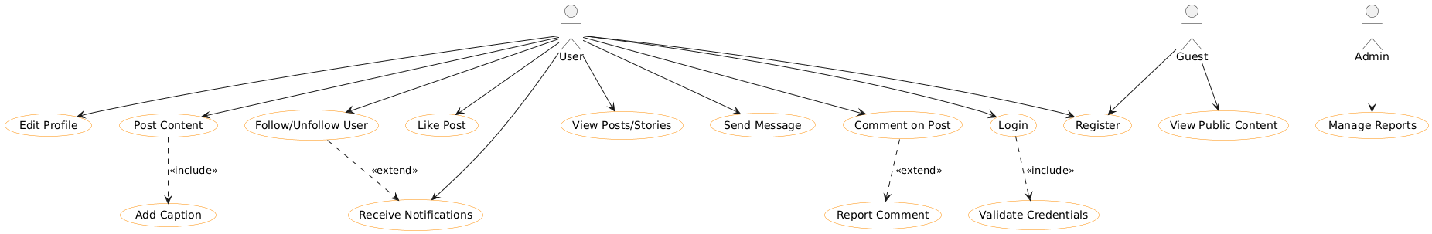

ClassDiagram:
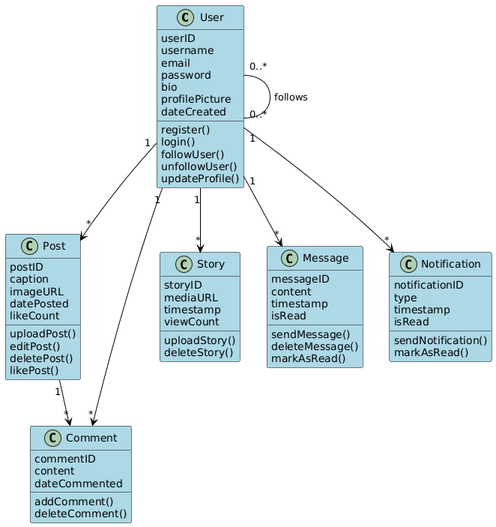

ActivityDiagram:
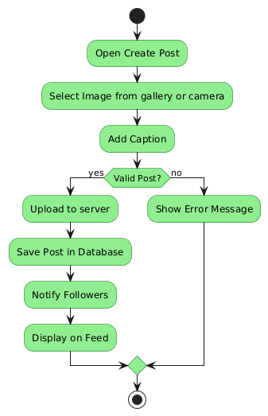

DFD(LEVEL1):

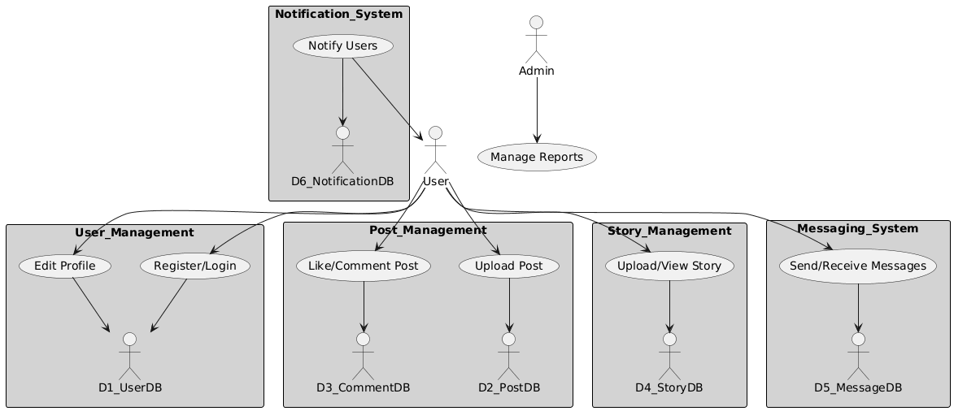

7.PERT AND GNATT CHART:
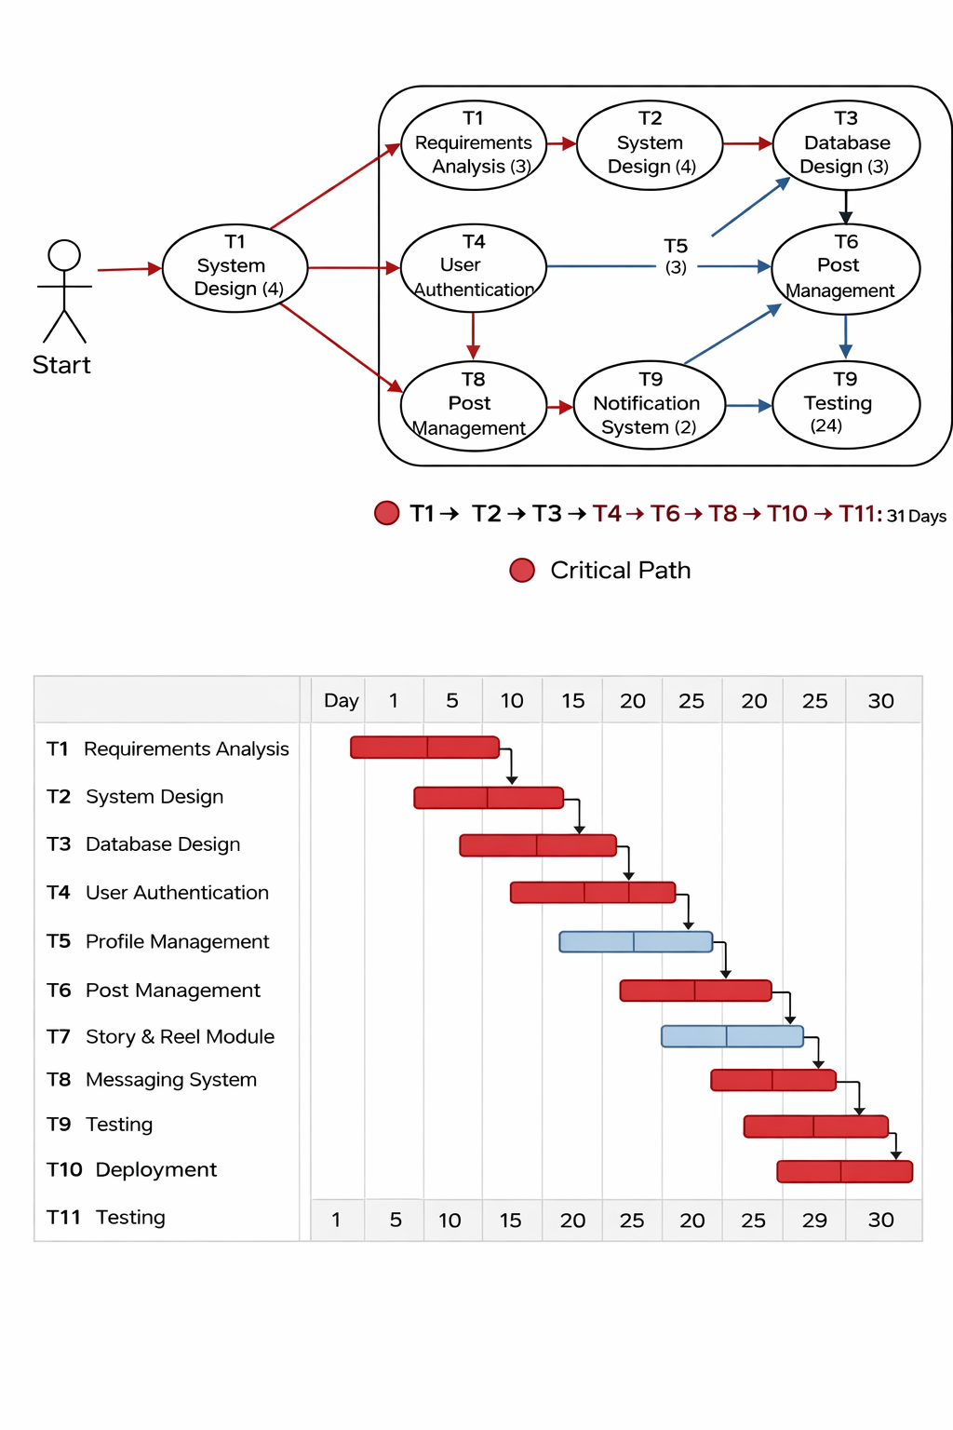

PERT Chart – Brief Explanation
The PERT chart represents the project scheduling and task dependencies. It highlights the sequence of activities, estimates task durations, and identifies the critical path, which determines the minimum time required to complete the project.

Gantt Chart – Brief Explanation
The Gantt chart provides a visual timeline of the project schedule. It displays task durations, start and end times, and overlaps between tasks, making it easier to track project progress and manage deadlines.

8.Tasks for each Member
